Air safety Infographics

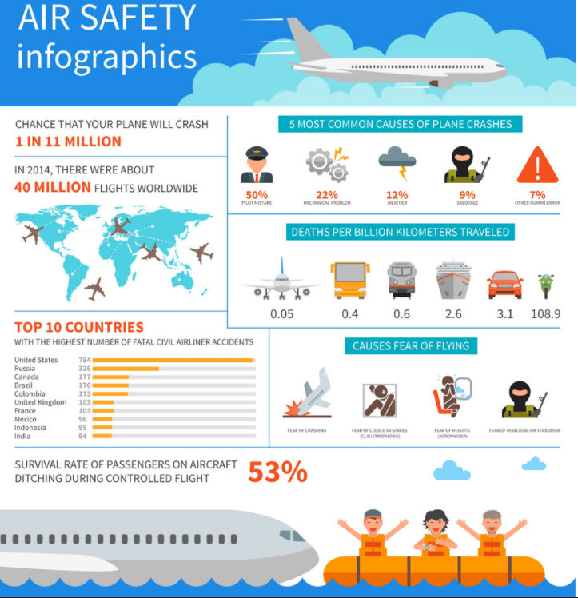

Aviation is the safest form of long distance transport. In 2018, the all accident rate (measured in accidents per 1 million flights) was 1.35, which was the equivalent of one accident for every 740,000 flights. This was an improvement over the all accident rate of 1.79 for the previous 5-year period (2013-2017),

Concretely, the 2018 fatality risk of 0.17 means that on average, a person would have to travel by air every day for 16,581 years to experience a 100% fatal accident.

References

IATA <https://www.iata.org/en/youandiata/travelers/aviation-safety/#:~:text=Flying%20is%20the%20safest%20form,for%20every%204.2%20million%20flights>.

Github:

<https://app.circleci.com/pipelines/github/Mfrakso/Airplane-Safety>